Subject "Pharmaceutical chemistry 2"
Lecture 9. Hemostatic and anticoagulant drugs. Antiplatelet drugs, thrombolytics, antianemics, plasma substitutes.

Normally, there are two balanced systems in the human body: coagulation and anticoagulation. The first prevents prolonged heavy bleeding, the second - prevents the formation of blood clots. The ability of blood to clot is an important defense mechanism against death due to blood loss. But he doesn't always get the job done. In surgery, traumatology, disaster medicine, with hemophilia, hemostatics are simply indispensable.
Medicinal herbs that have a hemostatic effect have been known for centuries. Shepherd's purse, yarrow, nettle leaves were used by ancient healers as hemostatics. The hemostatic effects of the tincture of the mountaineer pepper, decoction of the bark of the common viburnum, plantain leaves have long been known. From time immemorial, dry moss has been applied to an open wound. But herbs almost did not solve the problem, mortality from blood loss remained high. More effective means were needed, and things did not move quickly.
Only in 1883 did scientific research lead the French biologist G. Hayem to the discovery of the platelet. In 1890, the role of calcium in blood clotting was proven. In 1916, heparin, a substance that prevents blood coagulation, was discovered and described in 1918. In 1931, a Canadian veterinarian accidentally discovered warfarin, an indirect anticoagulant. The main physiological anticoagulant - protein C - was discovered and described in 1976. When the enemy is identified, it is easier to fight him. The successive discovery and description of the action of three anticoagulants allowed scientists to begin the development of new hemostatic agents. Since the late 60s of the last century, the production of effective hemostatic drugs gradually began. Today, medicine has a wide variety of modern hemostatics.
Classification of medicinal substances affecting homeostasis.
- Hemostatics
1. Coagulants (agents that stimulate the formation of fibrin thrombi):
a) direct action (thrombin, fibrinogen);
b) indirect action (vikasol, phytomenadione).
2. Fibrinolysis inhibitors:
a) synthetic origin (aminocaproic and tranexamic acids, amben);
b) animal origin (aprotinin, contrykal, pantrypin, gordox);
3. Stimulants of platelet aggregation (serotonin adipate, calcium chloride).
4. Means that reduce vascular permeability:
a) synthetic (adroxon, etamsylate, iprazochrome); b) vitamin preparations (ascorbic acid, rutin, quercetin).
c) herbal preparations (nettle, yarrow, viburnum, water pepper, arnica, etc.)
II. Anti-clotting agents or antithrombotic agents:
1. Anticoagulants:
a) direct action (heparin and its preparations, hirudin, sodium citrate, antithrombin III);
b) indirect action (neodicoumarin, syncumar, phenylin, fepromarone).
2. Fibrinolytics:
a) direct action (fibrinolysin or plasmin);
b) indirect (plasminogen activators) action (streptolyase, streptokinase, urokinase, actilyse).
3. Antiplatelet agents:
a) platelets (acetylsalicylic acid, dipyridamole, pentoxifylline, ticlopidine, indobufen);
b) erythrocyte (pentoxifylline, reopoliglyukin, reogluman, Rondex).
Means that increase blood clotting (hemostatics) coagulants
According to the classification, this group of drugs is divided into direct and indirect coagulants, but sometimes they are divided according to a different principle:
1) for local use (thrombin, hemostatic sponge, fibrin film, etc.)
2) for systemic use (fibrinogen, vikasol).

THROMBIN
(Trombinum; dry powder in amp. o, 1, which corresponds to 125 units of activity; in vials of 10 ml) is a direct-acting coagulant for topical use. Being a natural component of the blood coagulation system, it causes an effect in vitro and in vivo.
Before use, the powder is dissolved in saline. Usually the powder in the ampoule is a mixture of thromboplastin, calcium and prothrombin.
Apply only locally. Assign to patients with bleeding from small vessels and parenchymal organs (surgery on the liver, kidneys, lungs, brain), bleeding from the gums. It is used topically in the form of a hemostatic sponge soaked in thrombin solution, a hemostatic collagen sponge, or simply by applying a swab soaked in thrombin solution.
homeostasis.
Sometimes, especially in pediatrics, thrombin is used orally (the contents of the ampoule are dissolved in 50 ml of sodium chloride or 50 ml of 5% amben solution, 1 tablespoon is prescribed 2-3 times a day) for gastric bleeding or by inhalation for bleeding from the respiratory tract.
FIBRINOGEN
(Fibrinogenum; in vials of 1.0 and 2.0 dry porous mass) - used for systemic exposure. It is also obtained from the blood plasma of donors. Under the influence of thrombin, fibrinogen is converted into fibrin, which forms blood clots.
Fibrinogen is used as an ambulance. It is especially effective when its deficiency is observed in massive bleeding (placental abruption, hypo- and afibrinogenemia, in surgical, obstetric, gynecological and oncological practice).
Assign usually in a vein, sometimes locally in the form of a film applied to the bleeding surface.
Before use, the drug is dissolved in 250 or 500 ml of warm water for injection. Intravenously administered drip or slowly jet.
VIKASOL
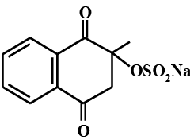
(Vicasolum; in tabs, 0.015 each and in 1 ml amp. 1% solution) indirect coagulant, a synthetic water-soluble analogue of vitamin K, which activates the formation of fibrin clots. Referred to as vitamin K3. The pharmacological effect is caused not by vikasol itself, but by the vitamins K1 and K2 formed from it, so the effect develops after 12-24 hours, with intravenous administration - after 30 minutes, with intramuscular injection - after 2-3 hours.
Obtaining vikasol:
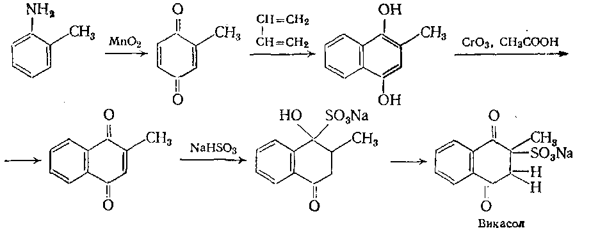
These vitamins are necessary for the synthesis in the liver of prothrombin (factor II), proconvertin (factor VII), as well as factors IX and X.
Indications for use: with an excessive decrease in the prothrombin index, with severe K-vitamin deficiency due to:
1) bleeding from parenchymal organs;
2) exchange transfusion procedure, if canned blood was transfused (to the child);
and also when:
3) long-term use of vitamin K antagonists - aspirin and NSAIDs (which disrupt platelet aggregation);
4) long-term use of broad-spectrum antibiotics (levomycetin, ampicillin, tetracycline, aminoglycosides, fluoroquinolones);
5) the use of sulfonamides;
6) prevention of hemorrhagic disease of newborns;
7) prolonged diarrhea in children;
8) cystic fibrosis;
9) in pregnant women, especially those suffering from tuberculosis and epilepsy and receiving appropriate treatment;
10) overdose of indirect anticoagulants;
11) jaundice, hepatitis, as well as after injuries, bleeding (hemorrhoids, ulcers, radiation sickness);
12) preparation for surgery and in the postoperative period.
The effects can be weakened with the simultaneous appointment of vikasol antagonists: aspirin, NSAIDs, PASK, indirect anticoagulants of the neodicoumarin group.
Side effects: hemolysis of erythrocytes when administered intravenously.
PHYTOMENADION
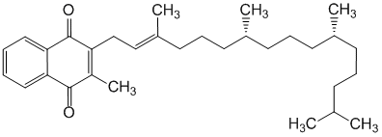
(Phytomenadinum; 1 ml for intravenous administration, as well as capsules containing 0.1 ml of a 10% oil solution, which corresponds to 0.01 of the drug). Unlike natural vitamin K1 (trans compounds) is a synthetic drug. It represents a racemic form (a mixture of trans- and cis-isomers), and in terms of biological activity it retains all the properties of vitamin K1. It is rapidly absorbed and maintains a peak concentration of up to eight hours.
Indications for use: hemorrhagic syndrome with hypoprothrombinemia caused by a decrease in liver function (hepatitis, liver cirrhosis), with ulcerative colitis, with an overdose of anticoagulants, with prolonged use of high doses of broad-spectrum antibiotics and sulfonamides; before major operations to reduce bleeding.
Side effects: phenomena of hypercoagulability in case of non-compliance with the dosing regimen.
Of the drugs related to direct-acting coagulants, the following drugs are also used in the clinic:
1) prothrombin complex (VI, VII, IX, X factors);
2) antihemophilic globulin (VIII factor).
Fibrinolysis inhibitors (antifibrinolytics)
AMINOCAPROIC ACID (ACC)
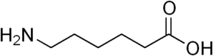

A powdered synthetic drug that inhibits the conversion of profibrinolysin (plasminogen) into fibrinolysin (plasmin) by acting on the profibrinolysin activator and thereby contributes to the preservation of fibrin thrombi.
Receipt:
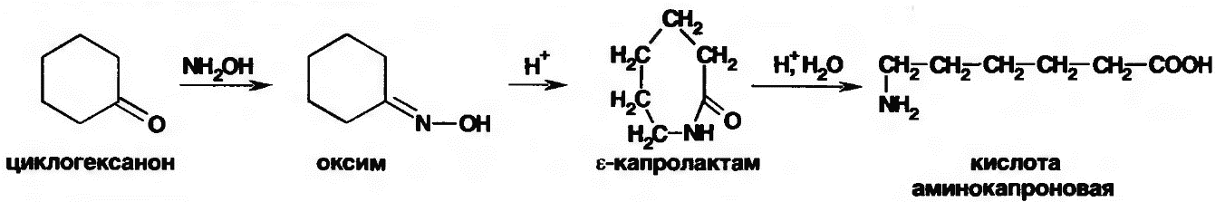
In addition, ACC is also an inhibitor of kinins and some complement system factors.
It has anti-shock activity (inhibits proteolytic enzymes, and also stimulates the neutralizing function of the liver).
The drug has low toxicity, is quickly excreted from the body with urine (after 4 hours).
They are used in the emergency clinic, during surgical interventions and in various pathological conditions, when the fibrinolytic activity of blood and tissues is increased:
1) during and after operations on the lungs, prostate, pancreas and thyroid glands;
2) with premature detachment of the placenta, prolonged retention in the uterus of a dead fetus;
3) with hepatitis, cirrhosis of the liver, with portal hypertension, when using a heart-lung machine;
4) in II and III stages of DIC syndrome, with ulcerative, nasal, pulmonary bleeding.
ACC is administered during massive transfusions of canned blood, administered intravenously or orally.
Available: powder and bottles of 100 ml of sterile 5% solution in isotonic sodium chloride solution. Due to the fact that ACC has anti-shock activity, inhibits proteolytic enzymes and kinins, inhibits the formation of antibodies, the drug is used in shock reactions and as an anti-allergic agent.
Side effects: possible dizziness, nausea, diarrhea, mild catarrh of the upper respiratory tract.
AMBEN (Ambenum, aminomethylbenzoic acid)
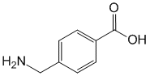
Synthetic drug, similar in chemical structure to para-aminobenzoic acid. White powder, poorly soluble in water. It is an antifibrinolytic agent. Amben inhibits fibrinolysis, the mechanism of action is similar to ACC.
Indications for use are the same. Assign intravenously, intramuscularly and inside. When injected into a vein, it acts quickly, but for a short time (3 hours). Release form: ampoules of 5 ml of 1% solution, tablets of 0.25.
Sometimes anti-enzymatic drugs are indicated, in particular, contrykal. It inhibits plasmin, collagenases, trypsin, chymotrypsin, which play an important role in the development of many pathophysiological processes. The drugs of this group have an inhibitory effect on the catalytic interaction of individual factors of fibrinolysis and blood coagulation processes.
Indications for use: local hyperfibrinolysis - postoperative and postportal bleeding; hypermenorrhea; generalized primary and secondary hyperfibrinolysis in obstetrics and surgery; the initial stage of DIC, etc.
Side effect: rarely allergies; embryotoxic action; With a quick introduction - malaise, nausea.

Agents that increase platelet aggregation and adhesion
Serotonin
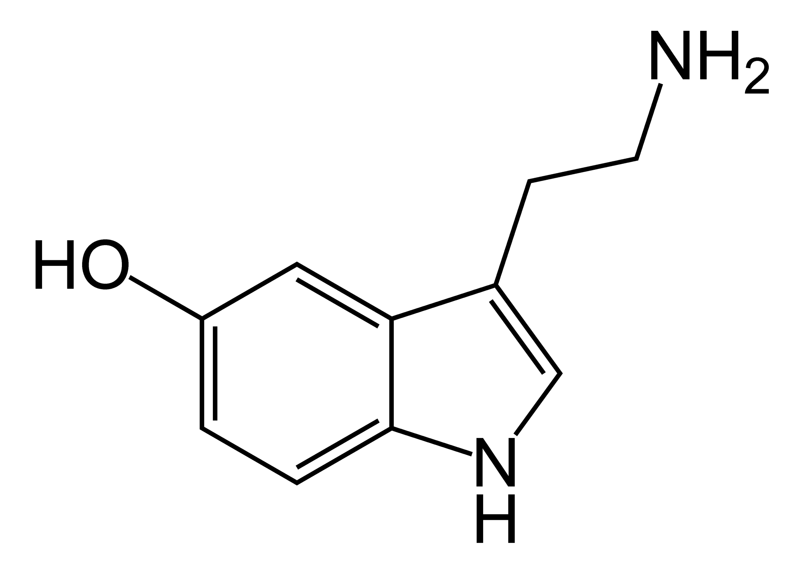

Its use is associated with stimulation of platelet aggregation, tissue swelling, changes in microcirculation, which contributes to the occurrence of platelet thrombi.
Receipt:
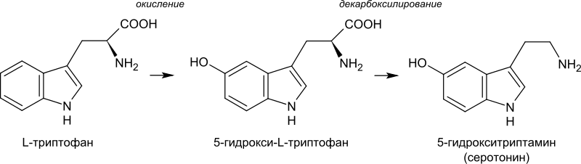
Serotonin in the form of adipinate (Serotonini adipinatis in ampoules of 1 ml of 1% solution) is used intravenously or intramuscularly for hemorrhages associated with platelet pathology (thrombocytopenia, thrombocytopathy). This increases the number of platelets, shortens the bleeding time, increases the resistance of capillaries.
Used for von Willebrandt type I disease, hypo- and aplastic anemia, for Werlhof's disease, hemorrhagic vasculitis.
Do not use in case of kidney pathology, patients with bronchial asthma, with blood hypercoagulation.
Side effect: with a quick introduction - pain along the vein; pain in the abdomen, in the region of the heart, rise in blood pressure, heaviness in the head, nausea, diarrhea, decreased diuresis.
CALCIUM PREPARATIONS
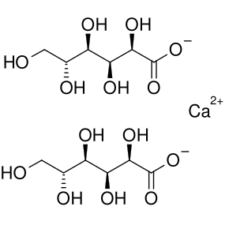
Calcium gluconate
CALCIUM is directly involved in platelet aggregation and adhesion, and also promotes the formation of thrombin and fibrin. Thus, it stimulates the formation of both platelet and fibrin clots.
Indications for use:
1) as a means of reducing vascular permeability, with hemorrhagic vasculitis;
2) as a hemostatic agent for pulmonary, gastric, nasal, uterine bleeding, as well as before surgery;
3) with bleeding associated with a decrease in calcium
in blood plasma (after transfusion of large amounts of citrated blood, plasma substitutes).
Calcium chloride is used (intravenously and orally).
Side effects: with rapid administration, cardiac arrest, lowering blood pressure are possible; with intravenous administration, there is a feeling of heat ("hot injection"); with subcutaneous administration of calcium chloride - tissue necrosis.

DRUGS THAT DECREASE THE PERMEABILITY OF THE VASCULAR WALL.
SYNTHETICS
ADROXONE (Adroxonum; in 1 ml amp. 0.025%)
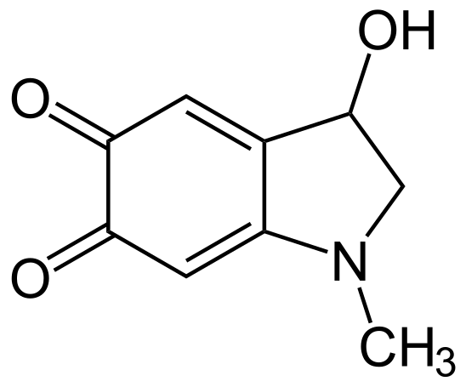
Adrenochrome, a metabolite of adrenaline. It does not increase blood pressure, does not affect the activity of the heart and blood clotting.
Its main effect is to increase the density of the vascular wall and activate platelet aggregation and adhesion. Therefore, adroxon has a hemostatic effect in capillary bleeding, when the permeability of the walls of these vessels is especially increased. However, with massive bleeding, the drug is not effective.
Indications for use:
1) with parenchymal and capillary bleeding;
2) in case of injuries and operations;
3) with intestinal bleeding in newborns;
4) with melena;
5) with platelet purpura.
Adroxon is applied topically (tampons, wipes), intramuscularly or subcutaneously.
ETAMSILATE or dicynone (Ethamsylatum; in tab. 0.25 and in amp. 2 ml of 12.5% ​​solution)
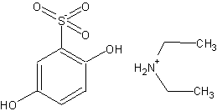
Synthetic, derivative of dioxybenzene. The drug reduces vascular permeability, reduces extravasation and exudation of the liquid part of the plasma, normalizes the permeability of the vascular wall and improves microcirculation, increases blood clotting, as it promotes the formation of thromboplastin (hemostatic effect). The last effect develops quickly - with intravenous administration after 5-15 minutes, the most pronounced - after 1-2 hours. In tablets, the effect is manifested after 3 hours. The drug is administered into a vein, subcutaneously or intramuscularly.
Indications for use:
1) platelet purpura;
2) intestinal and pulmonary bleeding (surgery);
3) hemorrhagic diathesis;
4) operations on ENT organs;
5) diabetic angiopathy (ophthalmology).
Side effect - sometimes there is heartburn, a feeling of heaviness in the epigastric region, headache, dizziness, flushing of the face, paresthesia of the legs, lowering blood pressure.
VITAMIN PREPARATIONS
To eliminate increased vascular permeability, especially in the presence of hemorrhages, vitamin C (ascorbic acid) preparations are used, as well as various flavonoids (rutin, ascorutin, quercetin, vitamin P), as well as vitamers, that is, semi-synthetic derivatives - venoruton and troxevasin in various medicinal products. forms (capsules, gel, solutions). Vitamin P preparations are used for intense extravasation of the liquid part of the plasma, for example, with swelling of the legs (thrombophlebitis). In addition, these drugs are prescribed for hemorrhagic diathesis, retinal hemorrhages, radiation sickness, arachnoiditis, hypertension, and an overdose of salicylates. Rutin and ascorutin are used in pediatrics to eliminate intense extravasation in children with scarlet fever, measles, diphtheria and toxic influenza.
RUTIN is available in tablets of 0.02 (2-3 times a day).
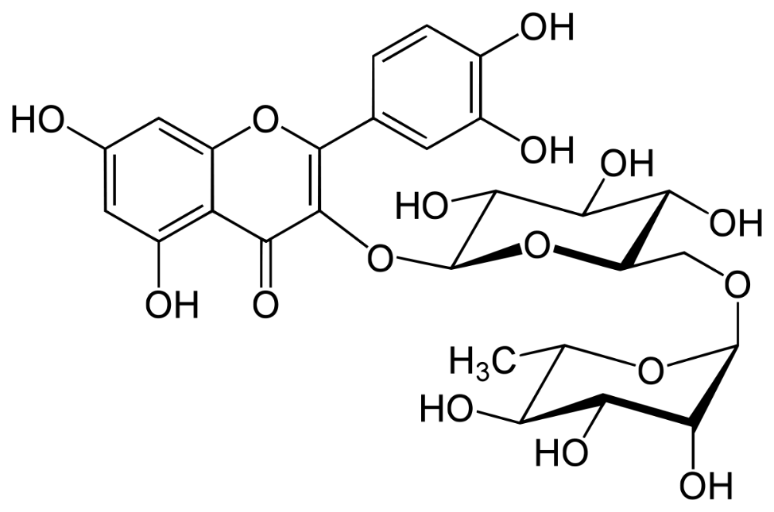
ASKORUTIN - 0.05 each. VENORUTON - in capsules 0.3 each; ampoules of 5 ml of a 10% solution. Preparations from plants (infusions, extracts, tablets) have a weak hemostatic effect. Therefore, they are used for light bleeding (nasal, hemorrhoidal), for bleeding, hemoptysis, hemorrhagic diathesis, in obstetric and gynecological practice.
Blood clotting agents (antithrombotics) anticoagulants
1. Anticoagulants (drugs that disrupt the formation of fibrin clots):
a) direct anticoagulants (heparin and its preparations, hirudin, sodium hydrocitrate, antithrombin III concentrate) - cause an effect in vitro and in vivo;
b) anticoagulants of indirect action (derivatives
oxycoumarin: neodicoumarin, sincumar, pelentan, etc.; indandione derivatives - phenyline, etc.)
- cause effect only in vivo.
HEPARIN (Heparinum; in a 5 ml vial containing 5000, 10000 and 20000 IU per 1 ml, "Gedeon Richter", Hungary).
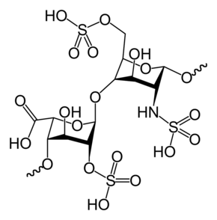
A natural anti-clotting factor produced by mast cells. Heparin is the collective name for a group of linear anionic polyelectrolytes distinguished by the number of sulfuric acid residues. There are high and low molecular weight heparins (average molecular weight -
Heparin is a novogalenic drug derived from the lungs and liver of cattle. It is the strongest organic acid due to the residues of its sulfuric acid and the presence of carboxyl groups, which gives it a very strong negative charge. Therefore, it, in fact, refers to anionic polyelectrolytes. Due to the negative charge, in the blood, heparin combines with positively charged complexes, is sorbed on the surface of the membranes of endothelial cells, macrophages, thereby limiting platelet aggregation and adhesion. The action of heparin largely depends on the plasma concentration of antithrombin III.
Pharmacological effects of heparin:
1) heparin has an anticoagulant effect, since it activates antithrombin III and irreversibly inhibits coagulation factors IXa, Xa, XIa and XIIa
systems;
2) moderately reduces platelet aggregation;
3) heparin reduces blood viscosity, reduces permeability
vascular capacity, which facilitates and accelerates blood flow, prevents the development of stasis (one of the factors contributing to thrombosis);
4) reduces the content of sugar, lipids and chylomicrons in the blood, has an anti-sclerotic effect, binds some components of the compliment, inhibits the synthesis of immunoglobulins, ACTH, aldosterone, and also binds histamine, serotonin, thereby showing an anti-allergic effect;
5) heparin has potassium-sparing, anti-inflammatory, analgesic effects. In addition, heparin increases diuresis and reduces vascular resistance due to the expansion of resistive vessels, eliminates spasm of the coronary arteries.
Indications for use:
1) with acute thrombosis, thromboembolism (acute myocardial infarction, thrombosis of the pulmonary artery, renal veins, ileocecal vessels), thromboembolism in pregnant women;
2) when working with heart-lung machines, artificial kidneys and hearts;
3) in laboratory practice;
4) with burns and frostbite (improvement of microcirculation);
5) in the treatment of patients in the initial stages of DIC (with fulminant purpura, severe gastroenteritis);
6) in the treatment of patients with bronchial asthma, rheumatism, as well as in the complex therapy of patients with glomerulonephritis;
7) during extracorporeal hemodialysis, hemosorption and forced diuresis;
8) with hyperaldosteronism;
9) as an antiallergic agent (bronchial asthma);
10) in the complex of therapeutic measures in patients with atherosclerosis.
Side effects:
1) development of hemorrhages, thrombocytopenia (30%);
2) dizziness, nausea, vomiting, anorexia, diarrhea;
3) allergic reactions, hyperthermia.
To eliminate complications (hemorrhages), heparin antidotes are injected into the vein (protamine sulfate in the form of a 5% solution or POLYBREN; 1 mg of protamine sulfate neutralizes 85 IU of heparin; inject slowly).
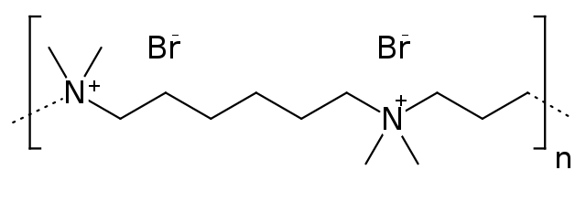
Polybren
At one time, a patient with acute thrombosis, on average, is administered 10,000 IU intravenously. Up to 40,000 - 50,000 IU intravenously per day, administered slowly. It can be administered intramuscularly and subcutaneously (in the area of ​​least vascularization). In recent years, for the prevention of thrombosis, it is recommended to administer 5000 IU of heparin subcutaneously or intradermally every 6-8 hours. Heparin ointment is also available in tubes of 25.0 (2500 units). Inhalation in the form of an aerosol, as an antiallergic agent, the drug is administered using an ultrasonic inhaler at 500 IU / kg per day. Inhalations are carried out 2-3 times a week. A single dose is diluted in distilled water in a ratio of 1: 4.
HIRUDIN and its preparations (girudont, etc.) are a product of leeches. The anticoagulant and anti-inflammatory effects of these agents are used. They are prescribed topically (ointments and gels) for superficial inflammation of the veins, vein thrombosis, trophic ulcers of the leg, furunculosis, inflammation of the lymph nodes, to improve the healing of sutures after injuries and burns.
Side effect - allergic reactions (rash, itching, Quincke's edema).
SODIUM HYDROCITRATE
Used only for blood preservation. The anion of citric acid combines with the calcium ion, which binds the activity of the latter. The substance is added in excess. The patient should not be used, since sodium hydrocitrate will block calcium ions and the patient will develop arrhythmia, possibly developing heart failure and cardiac arrest.
Sometimes prescribed orally to eliminate hypercalcemia and treat poisoning with cardiac glycosides.
If the patient is transfused up to 500 ml of canned blood, then this does not require any additional measures. If blood is transfused in a volume of more than 500 ml, then it is necessary to add 5 ml of a 10% solution of calcium chloride for every 50 ml in excess of 500 ml of transfused blood.
Indirect anticoagulants (oral anticoagulants)
Of the large number of anticoagulants, the most common drugs are the coumarin group. There are many drugs, but neodicoumarin (pelentan), sincumar, fepromarone, phenylin, amefin, farfavin are used more often than others.
NEODICUMARIN
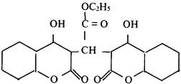

SINKUMAR (ASENOCUMAROL)
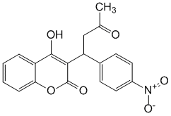
NITROFARIN
DIKUMARIN
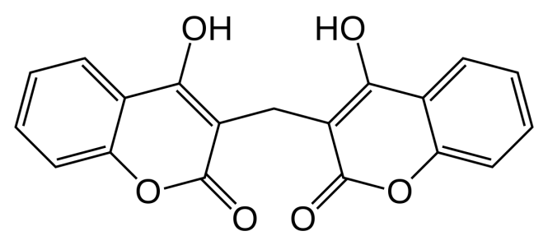

FEPROMARON
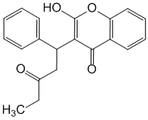
OMEFIN
FENILIN (FENINDION)
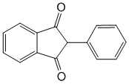
Derivatives of phenylindanedione, very similar in pharmacodynamics. Their mechanism of action is related to the fact that they are antivitamins K, that is, they act as vitamin K antagonists.
By suppressing its activity, these drugs inhibit the synthesis of proconvertin (factor VII), prothrombin (factor II), as well as IX and X coagulation factors necessary for coagulation homeostasis, that is, for the formation of fibrin thrombi. These drugs do not act immediately, but after 8-24 hours, that is, they are slow-acting agents with cumulative properties. At the same time, different drugs of this group have different speed and strength of action, different degrees of cumulation. Another feature of their action is the high duration of action.
These drugs are used only inside, as they are well absorbed, then they are brought back to the intestine with the blood flow, released into its lumen and absorbed again (recirculation). All drugs enter into an unstable relationship with plasma proteins and are easily displaced from it by other drugs. They only work in vivo.
Indications for use:
1) to reduce blood clotting in order to prevent and treat thrombosis, thrombophlebitis and thromboembolism (myocardial infarction), embolic strokes;
2) in surgery to prevent thrombus formation in the postoperative period.
Side effects are rarely recorded in the form of dyspeptic syndrome (nausea, vomiting, diarrhea, loss of appetite). In the course of pharmacotherapy with drugs such as neodicoumarin, there are complications in the form of bleeding due to an overdose, with a properly selected dose, but without taking into account drug interactions. For example, with the simultaneous appointment of neodicoumarin and butadione or salicylates. In this case, bleeding is also possible through an intact vascular wall, for example, in patients with peptic ulcer. Treatment should be carried out under constant monitoring of the level of prothrombin in the blood. In case of bleeding, a solution of vikasol, vitamin P, rutin, calcium chloride is administered, and 70-100 ml of the donor's blood is transfused.
Treatment with anticoagulants is a difficult task for the doctor. It is necessary to monitor the prothrombin index, which should be 40-50. Treatment is strictly individual.
There are a number of contraindications to the use of this group of funds:
1) open wounds, stomach ulcer;
2) endocarditis;
3) hepatitis, liver cirrhosis;
4) threatened abortion;
5) kidney disease.

Fibrinolytics (thrombolytics)
1. Direct action - fibrinolysin (plasmin).
2. Indirect action (plasminogen activators: actilyse, streptokinase, streptodecase, urokinase).
FIBRINOLISIN (available as a powder in vials containing 10, 20, 30 and 40 thousand units).
An old drug that is a fibrinolytic. It is obtained from the blood plasma of a donor. As a proteolytic enzyme, it breaks down fibrin, acting on the surface of the thrombus. It eliminates only fibrin thrombi during the first days of their formation, dissolves only fresh fibrin strands in the veins, leading to vascular recanalization.
Fibrin degradation products have anticoagulant properties, as they inhibit the polymerization of fibrin monomers and the formation of thromboplastin.
Fibrinolysin is an emergency drug prescribed for thromboembolic conditions:
- peripheral vascular occlusion;
- thrombosis of the vessels of the brain, eyes;
- IHD (myocardial infarction);
- when removing a thrombus from a vascular shunt.
This drug has significant drawbacks: - it is very expensive (produced from donated blood); - not very active, poorly penetrates into the thrombus. Side effects with the introduction of fibrinolysin, a foreign protein, can be realized in the form of allergic reactions, as well as in the form of non-specific reactions to the protein (face flushing, pain along the vein, as well as behind the sternum and in the abdomen) or in the form of fever, urticaria.
Before use, the drug is dissolved in an isotonic solution at the rate of 100-160 IU of fibrinolysin per 1 ml of solvent. The prepared solution is poured intravenously drip (10-15 drops per minute).
Fibrinolytics of indirect action
STREPTOKINASE (streptase, avelizin; available in amps containing 250,000 and 500,000 IU of the drug).
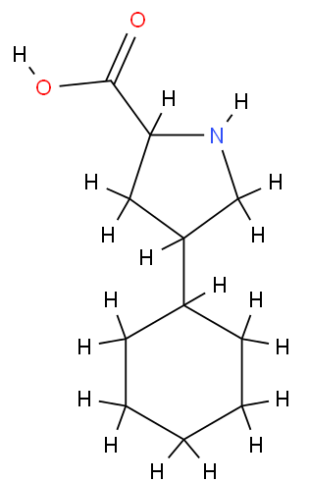
Более современный препарат, непрямой фибринолитик. Его получают из бета-гемолитического стрептококка. Это более активный и дешевый препарат. Он стимулирует переход проактиватора в активатор, трансформирующий профибринолизин в фибринолизин (плазмин). Препарат способен проникать внутрь тромба (активируя в нем фибринолиз), что выгодно отличает его от фибринолизина. Стрептокиназа наиболее эффективна при
действии на тромб, который образовался не более семи дней назад. При этом данный фибринолитик способен восстанавливать проходимость кровеносных сосудов, распад тромбов.
Показания к применению :
1) при лечении больных с поверхностными и глубокими
тромбофлебитами;
2) при тромбоэмболиях легочных сосудов и сосудов глаза;
3) при септических тромбозах;
4) при свежем (остром) инфаркте миокарда. Побочные эффекты : 1) аллергические реакции (антитела к стрептококкам); 2) геморрагии; 3) падение уровня гемоглобина, гемолиз эритроцитов (прямое токсическое действие);
4) вазопатии (образование ЦИК).
УРОКИНАЗА - препарат, синтезируемый из мочи. Считается более современным средством, в меньшей степени дает аллергические реакции, чем стрептокиназа.
Общее замечание: при применении большого количества фибринолитиков в организме компенсаторно развиваются процессы свертывания крови. Поэтому все эти препараты необходимо вводить вместе с гепарином. Кроме того, используя данную группу средств, постоянно контролируют уровень фибриногена и тромбиновое время.

Средства, препятствующие агрегации тромбоцитов (антиагреганты)
Антиагреганты - группа противосвертывающих средств :
1. Тромбоцитарные (ацетилсалициловая кислота (АСК), гепарин, дипиридамол, тиклопидин, индобуфен, пентоксифиллин).
2. Эритроцитарные (пентоксифиллин, реополиглюкин).
АЦЕТИЛСАЛИЦИЛОВАЯ КИСЛОТА (Acidum acetylsalicylicum; в таб. по 0, 25)
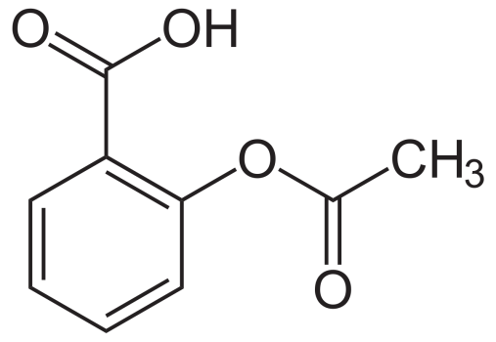
It is a vitamin K antagonist and is capable of irreversibly blocking platelet cyclooxygenase. Due to this, the formation of metabolites of arachidonic acid, in particular, aggregating prostaglandins and thromboxane A, which is the most powerful endogenous aggregant and vasoconstrictor, is rapidly reduced in them.
Receipt:
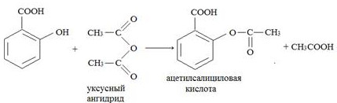

In addition to inhibition of platelet adhesion, ASA, being a vitamin K antagonist, disrupts the formation of fibrin clots in large doses.
It is necessary to note a number of very important points for the clinic:
1. Prevention of platelet aggregation ASA when using very low doses. The optimal dose for this effect is from 20 to 40 mg per day. Taking 30-40 mg of aspirin blocks platelet aggregation for 96 hours. A dose of 180 mg per day irreversibly inhibits the enzyme cyclooxygenase (COX). Large doses, equal to 1000-1500 mg of ASA per day, can suppress COX in the vascular wall, where another prostaglandin, prostacyclin J2, is formed. The latter prevents platelet aggregation and adhesion, and also causes vasodilation.
Thus, high doses of ASA cause COX inhibition both in platelets (which is desirable) and in the vascular wall (which is undesirable). The latter can provoke thrombosis.
2. ASA acts as an NSAID for several hours after administration. At the same time, the antiaggregation effect is long-term, as long as platelets live, that is, 7 days, since the inhibition of COX in them is an irreversible phenomenon, the enzyme is not synthesized again by the plate. After about a week, a new population of platelets is restored, with an appropriate supply of COX.
Taking into account these facts, one can understand why when taking small doses of ASA, clotting decreases, and bleeding does not occur.
Indications for the use of ASA (as an antiplatelet agent):
1) prevention of the occurrence of arterial blood clots;
2) with angina pectoris;
3) with hypertension;
4) with atherosclerosis.
As an antiplatelet agent, the drug is prescribed according to the scheme: the first day, 0.5 2 times, then 0.25 per day for several months, and sometimes years. To reduce the risk of ulcerogenesis, MICRISTIN has been released - a granular microcrystalline preparation of ASA, enclosed in a polyvinyl acetate shell.
For similar indications, indobufen, indomethacin are also prescribed.
DIPIRIDAMOL (Dypiridomalum; synonyms: chimes, persantyl; in a tablet or dragee of 0.025 and 0.075, as well as in 2 ml amp. of 0.5% solution).
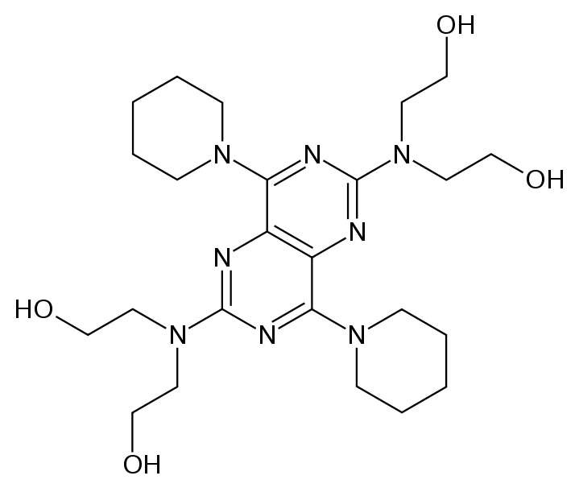
Antianginal agent. Competitive inhibitor of phosphodiesterase and adenosine deaminase. Dipyridamole prevents platelet aggregation by limiting aggregating factors in them (cAMP accumulates in platelets) and potentiating the action of adenosine. The latter promotes vasodilating and antiaggregatory effects, a slight decrease in blood pressure. Thus, the drug expands the coronary vessels and increases the rate of blood flow, improves the supply of oxygen to the myocardium. In general, the drug is considered a weak antiplatelet agent.
Indications for use:
1) to prevent thrombosis;
2) in the treatment of patients with DIC (in combination with heparin);
3) for the prevention of DIC in infectious toxicosis, septicemia (shock);
4) with dehydration;
5) in patients with heart valve prostheses;
6) with hemodialysis;
7) with angina pectoris and myocardial infarction.
Side effects: short-term reddening of the face, tachycardia, allergic reactions. A modern antiplatelet agent is the drug
TICLOPIDIN (Ticlopidinum; synonym - ticlid; in tab. 0, 25) - a new selective antiplatelet agent that is superior in strength to ASA.
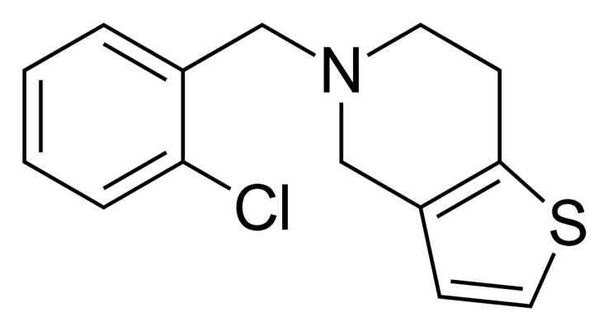
Ticlid inhibits platelet aggregation and adhesion. The drug stimulates the formation of prostaglandins Pg E1, Pg D2 and Pg J2, improves microcirculation.
Indications for use:
1) ischemic and cerebrovascular diseases;
2) ischemic heart disease;
3) limb ischemia;
4) retinopathy (diabetes mellitus, etc.);
5) when bypassing blood vessels.
Side effects: stomach pain, diarrhea, rash, dizziness, jaundice, decrease in the number of leukocytes and platelets.
Plasma-substituting drugs based on dextran, that is, low molecular weight dextrans (glucose polymers), are also used as antiplatelet agents. These are, first of all, solutions of the medium molecular fraction of dextran: 6% solution of polyglucin, 10% solution of reopoliglyukin (especially this drug), as well as reogluman, Rondex. These funds "dilute" the blood, reduce its viscosity, envelop platelets and erythrocytes, which contributes to their antiplatelet effect, improve the movement of fluid from tissues into the vessels, increase blood pressure, and have a detoxifying effect.
Indications for use: shock, thrombosis, thrombophlebitis, endarteritis, peritonitis, etc. (in order to improve capillary blood flow).
Side effects : allergic reactions.
Platelet antiaggregants are drugs from the group of methylxanthines: eufillin, as well as teonikol (xanthinol nicotinate, complavin, ksavin), etc.
TEONICOL (xanthinol nicotinate; in dragee 0, 15 and amp. 2 and 10 ml of 15% solution).
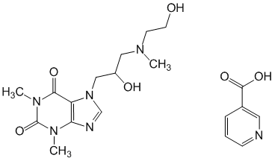
It has a vasodilating effect, improves cerebral circulation, reduces platelet aggregation.
Indications for use:
1) spasms of the vessels of the extremities (endoarteritis, Raynaud's disease);
2) trophic ulcers of the extremities.
Side effects: feeling of warmth, redness of the face, neck, general weakness, dizziness, pressure in the head, dyspepsia.
Agents that prevent erythrocyte aggregation
PENTOXYFILLIN or trental (Pentoxyphillinum; in dragee 0, 1 and in 5 ml amp. 2% solution).
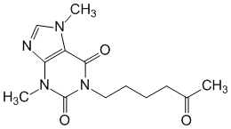

A dimethylxanthine derivative similar to theobromine. The main effect of the drug is to improve the rheological properties of blood. It contributes to the bendability of erythrocytes, which improves their passage through the capillaries (the diameter of erythrocytes is 7 microns, and the capillaries are 5 microns).
Since trental increases the flexibility of erythrocytes, limits the aggregation of blood cells, reduces the level of fibrinogen, it ultimately reduces the viscosity of the blood and makes it more fluid, reducing the resistance to blood flow. Improving the rheological properties of blood is slow. The effect comes in 2-4 weeks.
Indications for use:
1) in violation of peripheral circulation:
- Raynaud's disease;
- diabetic angiopathy;
- vascular pathology of the eye;
2) in violation of cerebral and coronary circulation;
3) with circulatory shock.
Trental is contraindicated in pregnancy, patients with hemorrhages and myocardial infarction. Undesirable effects: nausea, anorexia, diarrhea, dizziness, redness of the face.
Means that affect hematopoiesis
ANTIANEMIC MEANS
Antianemic agents are used to enhance hematopoiesis and eliminate qualitative disorders of erythropoiesis.
Anemia can develop as a result of insufficiency of various hematopoietic factors:
- iron (iron deficiency anemia);
- some vitamins (B12-deficient, folic acid-deficient, E-deficient);
- proteins (protein deficiency).
In addition, the role of hereditary disorders of erythropoiesis, copper and magnesium deficiency is very significant. There are hypochromic and hyperchromic anemias. Hyperchromic anemia occurs with a deficiency of B vitamins (folic acid - Bc and cyanocobalamin - B12). All other anemias are hypochromic. The incidence of anemia is high, especially among pregnant women.
Antianemic agents used in hypochromic anemia
Most often, hypochromic anemia is of iron deficiency origin. Iron deficiency can result from:
- insufficient intake of iron in the body of the fetus and child;
- poor absorption from the intestine (malabsorption syndrome, inflammatory bowel disease, taking tetracyclines and other antibiotics);
- excessive blood loss (worm infestation, nasal and hemorrhoidal bleeding);
- increased consumption of iron (intensive growth, infections).
Iron is an essential component of a number of enzymes of both hemic and non-himine structures. Hemic enzymes: - hemo- and myoglobin;
- cytochromes (P-450);
- peroxidase;
- catalase.
Non-heminic enzymes: - succinate dehydrogenase;
- acetyl-CoA dehydrogenase;
- NADH dehydrogenase etc.
With a lack of iron, the content of hemoglobin decreases (the color index is less than one), as well as the activity of respiratory enzymes in tissues (hypotrophy).
Iron is absorbed in the duodenum, as well as in other parts of the small intestine. Ferrous iron is well absorbed. The ferric iron received with food under the influence of hydrochloric acid of the stomach turns into ferrous iron. Calcium, phosphates contained in milk, especially cow's milk, phytic acid, tetracyclines prevent the absorption of iron. The maximum amount of iron (bivalent, which can enter the body per day, is 100 mg).
Iron is absorbed in two stages:
Stage I: iron is captured by mucosal cells.
This process is supported by folic acid.
Stage II: transport of iron through the mucosal cell and release it into the blood. Iron in the blood
oxidized to trivalent, binds to transferrin.
The more severe the iron deficiency anemia, the less saturated this protein is and the greater its capacity and ability to bind iron. Transferrin transports iron to the organs of hematopoiesis (bone marrow) or storage (liver, spleen).
For the treatment of patients with hypochromic anemia, drugs prescribed both orally and by injection are used.
Inside, ferrous iron preparations are mainly used, since it is better absorbed and less irritating to the mucous membrane.
In turn, drugs prescribed orally are divided into:
1. Organic iron preparations:
- iron lactate;
- ferrocal;
- hemostimulin;
- ferroplex;
- conference;
- ferroceron;
- aloe syrup with iron;
- ferramid.
2. Inorganic iron preparations:
- ferrous sulfate;
- iron chloride;
- iron carbonate.
The most accessible and cheapest drug is the preparation of ferrous iron sulfate (Ferrosi sulfas; tab. 0.2 (60 mg of iron)) and powders in gelatin capsules of 0.5 (200 mg of iron)). In this preparation - a high concentration of pure iron.
In addition to this drug, there are many others. IRON LACTATE (Ferri lactas; in gelatin capsules of 0.1-0.5 (1.0-190 mg of iron)).
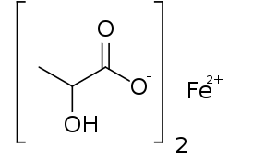
ALOE SYRUP WITH IRON (in 100 ml bottles) contains 20% ferrous chloride solution, citric acid, aloe juice. Use one teaspoon per dose in a quarter glass of water. Among the undesirable effects when taking this drug, dyspepsia is frequent.
FERROKAL (Ferrocallum; a combined official preparation containing 0.2 ferrous iron, 0.1 calcium fructose diphosphate and cerebrolecithin in one tablet). The drug is prescribed three times a day.
FERROPLEX - dragee containing ferrous sulfate and ascorbic acid. The latter sharply increases the absorption of iron.
FEFOL is a combination of iron and folic acid.
Long-acting drugs (TARDIFERON, FERRO - GRADUMET) are considered more modern, made using a special technology on an inert plastic sponge-like substance, from which iron is gradually released.
There are many drugs, you can use any, but it must be remembered that the therapeutic effect does not develop immediately, but after 3-4 weeks of taking the medicine. Often repeated courses are required. This means that side effects are primarily associated with the irritating effect of iron ions on the gastrointestinal mucosa (diarrhea, nausea). In 10% of patients, constipation develops, since ferrous iron binds hydrogen sulfide, which is a natural irritant of the gastrointestinal tract. There is staining of the teeth. Poisoning is possible, especially in children (capsules are sweet, colored).
Clinic of iron poisoning:
1) vomiting, diarrhea (feces become black);
2) blood pressure drops, tachycardia appears;
3) develops acidosis, shock, hypoxia, gastroenterocolitis.
The fight against acidosis - gastric lavage (3% soda solution). There is an antidote, which is a complexone. This is DEFEROXAMINE (desferal), which is also used for chronic aluminum poisoning. It is prescribed orally, intramuscularly or intravenously by drip at 60 mg / kg per day. Inside is assigned 5-10 grams. If this drug is not available, then TETACIN-CALCIUM can be prescribed intravenously.
Only in the most severe cases of hypochromic anemia, in case of impaired iron absorption, are resorted to drugs for parenteral administration.
FERKOVEN (Fercovenum) is administered intravenously, contains ferrous iron and cobalt. When administered, the drug causes pain along the vein, thrombosis and thrombophlebitis are possible, pain behind the sternum, facial flushing may appear. the drug is highly toxic.
FERRUM-LEK (Ferrum-lec; in amps of 2 and 5 ml) is a foreign drug for intramuscular and intravenous administration containing 100 mg of ferric iron in combination with maltose.
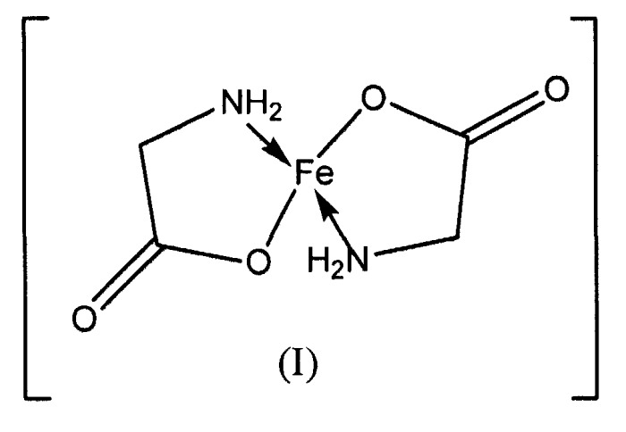
Ampoules for intravenous administration contain 100 mg of iron saccharate. The drug for intramuscular injection should not be used for intravenous administration. When prescribing the drug into a vein, the drug should be administered slowly, the contents of the ampoule must first be diluted in 10 ml of isotonic solution.
In the treatment of patients with hyperchromic anemia, vitamin preparations are used:
- vitamin B₁₂ (cyanocobalamin);
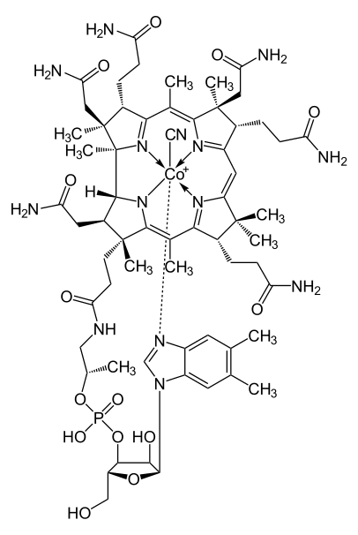
- Vitamin Bc (folic acid).
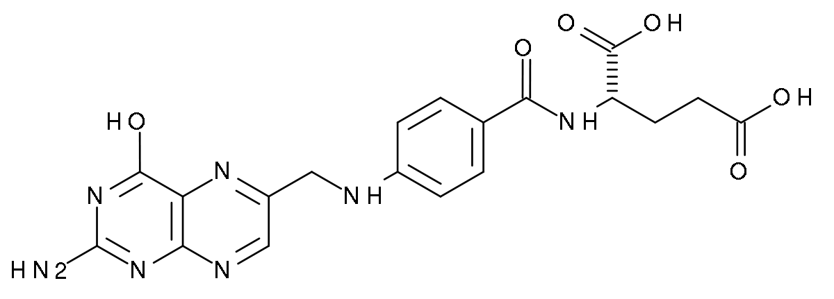
Cyanocobalamin is synthesized in the body by the intestinal microflora, and also comes with meat and dairy foods. In the liver, vitamin B12 is converted to coenzyme cobamamide, which is part of various reducing enzymes, in particular reductase, which converts inactive folic acid to biologically active folinic acid.
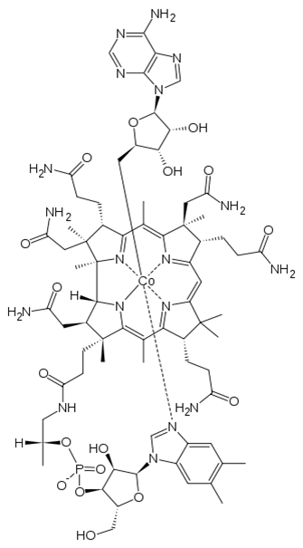
Thus, vitamin B₁₂:
1) activates the processes of hematopoiesis;
2) activates tissue regeneration;
Cobamamide, in turn, is necessary for the formation of deoxyribose and contributes to:
3) DNA synthesis;
4) completion of erythrocyte synthesis;
5) maintaining the activity of sulfhydryl groups in
glutathione, which protects red blood cells from hemolysis;
6) improvement of myelin synthesis.
For the assimilation of vitamin B12 from food, the internal factor of Castle is needed in the stomach. In its absence, immature erythrocytes - megaloblasts - appear in the blood.
The preparation of vitamin B12 CYANOCOBALAMIN (Cianocobalaminum; vyp. in 1 ml amp. 0.003%, 0.01%, 0.02% and 0.05% solution) - a means of replacement therapy, it is administered parenterally. In its structure, the drug has groups of cyan and cobalt.
The drug is shown:
- with malignant megaloblastic anemia of Addison-Birmer and after resection of the stomach, intestines;
- with diphylobotriosis in children;
- with terminal ileitis;
- with diverticulosis, sprue, celiac disease;
- with prolonged intestinal infections;
- in the treatment of malnutrition in premature babies;
- with radiculitis (improves myelin synthesis);
- with hepatitis, intoxication (promotes the formation of choline, which prevents the formation of fat in hepatocytes);
- with neuritis, paralysis.
It is used for hyperchromic anemia and folic acid (vitamin Bc). Its main source is the intestinal microflora. Comes with food (beans, spinach, asparagus, lettuce; egg white, yeast, liver). In the body, it turns into tetrahydrofolic (folinic) acid, necessary for the synthesis of nucleic acids and proteins. This transformation occurs under the influence of reductases activated by vitamin B12, ascorbic acid and biotin.
Especially important is the effect of folinic acid on cell division of rapidly proliferating tissues - the hematopoietic and mucous membranes of the gastrointestinal tract. Folinic acid is necessary for the synthesis of hemoproteins, in particular hemoglobin. It stimulates erythro-, leuko- and thrombopoiesis. In chronic folic acid deficiency, macrocytic anemia develops, in acute - agranulocytosis and aleukia.
Indications for use:
- necessarily together with cyanocobalamin in Addison-Birmer megaloblastic anemia;
- during pregnancy and lactation;
- in the treatment of patients with iron deficiency anemia, since folic acid is necessary for the normal absorption of iron and its inclusion in hemoglobin;
- with non-hereditary leukopenia, agranulocytosis, some thrombocytopenia;
- when prescribing to patients drugs that inhibit the intestinal flora that synthesize this vitamin (antibiotics, sulfonamides), as well as drugs that stimulate the neutralizing function of the liver (antiepileptic drugs: difenin, phenobarbital);
- children in the treatment of malnutrition (protein-synthesizing function);
- in the treatment of patients with peptic ulcer (regenerative function).
Plasma-substituting solutions are drugs that compensate for the deficiency of blood plasma or its individual components.
Plasma-substituting solutions, similar in composition to blood plasma and administered in large quantities, are called infusion solutions. These solutions are able to support the vital activity of the organism or isolated organs for some time without causing pathological changes.
An ideal drug for plasma replacement and fluid volume restoration should:
• quickly compensate for the loss of circulating blood volume;
• restore hemodynamic balance; normalize microcirculation;
• have a sufficiently long residence time in the blood vessels;
• improve rheology (fluidity) of circulating blood;
• ensure the delivery of oxygen to tissues;
• easily metabolized, not accumulated in tissues, easily excreted and well tolerated;
• have minimal impact on the immune system.
There are about 20 classifications of infusion solutions. Most often, plasma-mixing solutions are divided into 6 groups, according to the main functions of the blood, which carry out the direction of their action.
Classification of plasma-substituting solutions for medical purposes
1. Hemodynamic (volemic, anti-shock) solutions are designed to treat shock of various origins and restore hemodynamic disorders, including microcirculation, when using heart-lung machines for diluting blood during operations, etc.
2. Detoxification solutions that promote the elimination of toxins in case of intoxication of various etiologies.
3. Regulators of water-salt balance and acid-base balance: saline solutions (including oral rehydration mixtures), osmodiuretics. The solutions correct the composition of the blood during dehydration caused by diarrhea, cerebral edema, and toxicosis (there is an increase in renal hemodynamics).
4. Preparations for parenteral nutrition. Serve to provide energy resources of the body, delivery of nutrients to organs and tissues.
5. Oxygen carriers that restore the respiratory function of the blood.
6. Complex (polyfunctional) solutions.
The last two groups of solutions have recently been especially actively developed.
The general requirements for solutions for injections - non-pyrogenicity, sterility, stability, the absence of mechanical impurities for plasma-substituting solutions also impose specific requirements. Solutions must be isosmotic, isoionic, isohydric. Their viscosity should not exceed the viscosity of blood plasma.
Blood, which is a complex solution containing various non-electrolyte molecules (urea, glucose, etc.), ions (Na +, K +, C1, HC032_, etc.) and micelles (protein), has an osmotic pressure equal to the sum of the osmotic pressures contained in its ingredients. Various substances dissolved in the blood are not equally osmotically active. The main carriers of these properties are electrolytes and, above all, Na + and O ions, although their mass concentration there is relatively low. The leading role in maintaining osmotic homeostasis is played by sodium ions, which account for accounts for more than 90% of extracellular cations. To maintain normal osmotic pressure, even a small sodium deficiency cannot be replaced by any other cations, since such a replacement would be expressed in a sharp increase in the concentration of these cations in the extracellular fluid, which would inevitably result in severe disorders of the body's vital functions.
The osmotic pressure due to high molecular weight colloidal substances is called oncotic pressure. Despite the significant content of protein in plasma, its share in the creation of the total osmotic pressure of plasma is small, since the molar concentration of proteins is very low due to their very large molecular weight. In this regard, albumins (concentration 42 g/l) create an oncotic pressure of 0.6 mOsmol, and globulins and fibrinogen, whose molecular weight is even higher, create an oncotic pressure of 0.2 mOsmol.
The osmolarity of blood, determined by the total concentration of particles dissolved in it, under normal conditions is one of the biological constants. Expressed in milliosmoles per liter, plasma osmolarity in healthy people varies within narrow limits: 285 ± 5 mOsm / l, blood osmolarity is 300 + 5 mOsm / l. Normally, this indicator is regulated by osmoregulators.
Complications of infusion therapy include the infusion of infusion solutions without taking into account their osmolarity and pH value. This can lead not only to impaired blood clotting, the development of thrombosis and bleeding, but also cause severe damage to internal organs.
Hyperosmolar conditions result from acute and chronic heart failure, myocardial infarction, burns, sepsis, and the administration of mannitol.
Very often, hyperosmotic solutions are used alone or in combination with other solutions. Their frequent use leads to the potential risk of hyperosmolarity, which can have unsafe consequences. Rapid bolus infusion of hyperosmolar solutions can bring the body into a state of hyperosmolarity. It is very important to take into account and be able to calculate the physiological parameters of solutions, to explain possible deviations. There are concepts of osmolarity and osmolality.
Osmolality is the osmotic concentration, which is determined by the number of Osmoles of a solute per 1 kg of solvent (water).
Osmolarity is the osmotic concentration, which is expressed by the number of Osmoles of a solute per 1 liter of solution. For dilute solutions, which include infusion solutions, the ratio of osmolality and osmolarity is close to 1.
The first of the plasma-substituting solutions was the iso-osmotic solution of sodium chloride (1831) for dehydration caused by cholera. A solution of sodium chloride supports the vital activity of some organs, but with significant blood loss, the introduction of large volumes of isotonic sodium chloride solution is poorly tolerated by the body due to changes in the ionic ratio. There are symptoms of the so-called "salt fever" (fever, fever). Thus, the isosmoticity of the solution is a necessary, but not the only requirement that plasma-substituting solutions must meet. They must contain the necessary salt complex that recreates the composition of the blood plasma. Therefore, plasma-substituting solutions include K+, Ca2+, Mg2+, Na+ ions, etc.
Plasma-substituting solutions must be isohydric, i.e. correspond to the pH value of blood plasma in the range of 7.36-7.47. Isohydricity is the ability to maintain a constant concentration of hydrogen ions. During the life of cells and organs, acidic metabolic products are formed, which are normally neutralized by blood buffer systems, such as carbonate, phosphate, etc. The isohydricity of physiological solutions is achieved by introducing sodium bicarbonate, sodium hydrogen phosphate and sodium acetate.
When using infusion solutions, there is often a need for their long-term circulation when introduced into the bloodstream. For this purpose, substances are added that increase the viscosity of solutions, bringing it closer to the viscosity of human blood plasma. To increase the viscosity of solutions, the following are added: human blood, products of protein origin, synthetic high polymers. Plasma-substituting solutions containing substances that increase viscosity are used as anti-shock and detoxifying agents.
Of the synthetic high polymers, dextran is most commonly used, a water-soluble high polymer of glucose, which is obtained from beet sugar by enzymatic hydrolysis, i.e. exposure to microorganisms, namely Leuconoston mesenteroydes. At the same time, sucrose is converted into dextran with a molecular weight of 50,000 ± 10,000 daltons, from which polyglucin, rondex.
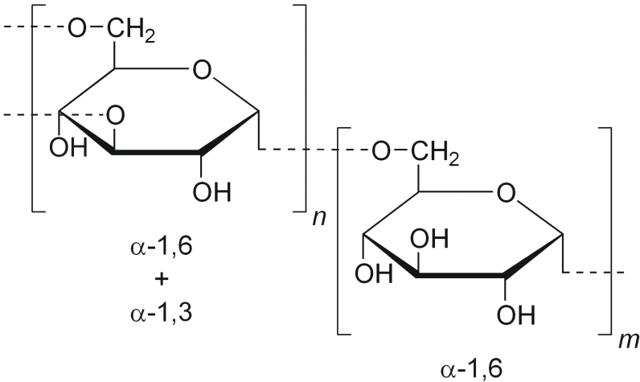
Plasma-substituting solutions containing proteins are used as means for parenteral nutrition: hydrolysin solution, casein hydrolyzate, aminopeptide, aminocrovin, fibrinosol, amikin, polyamine.
Basic drugs
1. Hemodynamic (anti-shock)
• Based on medium molecular weight dextran polyglucin, Rondex,
• Based on low molecular weight dextran - rheomacrodex.
• Based on gelatin - gelatinol, plasmogel, gemogel.
• Salt solutions (crystalloids) - Petrov's liquid.
2. Detoxification
• Based on low molecular weight polyvinylpyrrolidone gemodez, neogemodez, enterodez.
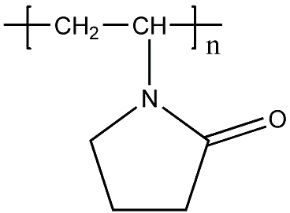
• Based on low molecular weight polyvinyl alcohol — polydez.

